**Multi-Threaded Visualisation Rubric (8th December 2016)**

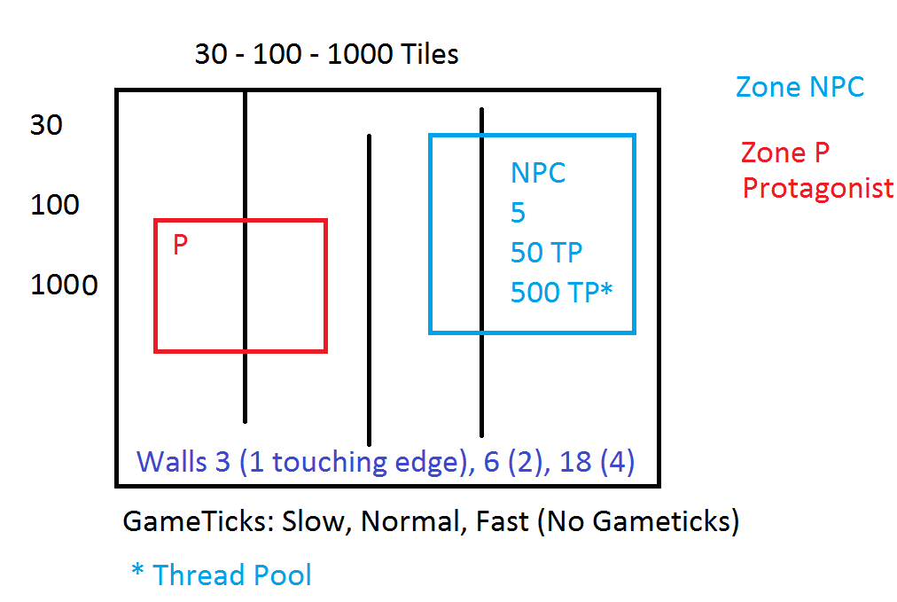

Produced SDL A* [Pathfinding Simulation](https://1drv.ms/p/s!Au3XD_Li32Zek5lGSuumkwzkJX8vyg). Simulation must include the following sub-systems:

* Input Management
  + Keyboard
* Primitive Shapes
  + Points
  + Lines
  + Circle
  + Rectangle
* Collision Detection
* Threading  
  At least one subsystem must be multi-threaded. The subsystem must be identified to invigilator. The introduction of threading must enhance performance (i.e increase FPS). SDL Threading of subsystem(s) must utilise:
  + <http://wiki.libsdl.org/SDL_CreateThread>
  + <https://wiki.libsdl.org/CategoryThread>
* Implementation of threading utilising
  + Mutex will be awarded a ***Basic Mark***
  + Critical Section will be awarded an ***Intermediate Mark***
  + Thread Pooling will be awarded an ***Advanced Mark***
* Please note Git commits will be checked week to week

**Marking Scheme (Practical 20%)**

|  |  |  |
| --- | --- | --- |
| **0 -35** | **35-75** | **75-100** |
| * A selection of the basic title requirements have been implemented to a basic level * Subsystem implementation will achieve minimum functionality * Title implementation may contain some syntax and/or run-time errors * Title implementation code will be poorly commented and/or formatted * Title implementation will contain basic features; application will not be tested properly * Title implementation code will not follow applicable coding conventions * Title implementation will not have a mechanism for human visualisation of current execution state using SDL and/or [Starter Kit](https://1drv.ms/f/s!Au3XD_Li32ZejaoHUzEPb6S3YxX1Ow). * Threaded implementation using a Mutex | * Title implementation requirement have been implemented to an acceptable level * Subsystem implementation will achieve expected functionality * Title implementation will not contain syntax and/or run-time errors * Title implementation code will be reasonably commented and/or formatted * Concurrent implementation will contain assignment features and course grained 2 process implementation * Title will be tested to a reasonable degree * Title implementation code will follow appropriate coding conventions * Title implementation will have a mechanism for human visualisation of concurrent execution using SDL and/or [Starter Kit](https://1drv.ms/f/s!Au3XD_Li32ZejaoHUzEPb6S3YxX1Ow). * Threaded implementation of a Critical Section | * Title implementation requirement have been implemented to an advanced level * Subsystem implementation will not contain syntax and/or run-time errors * Concurrent implementation code will be well commented and/or formatted * Title will be expertly tested * Title implementation of code will follow coding conventions * Title implementation will have an advanced mechanism for human visualisation of concurrent execution state using SDL and/or [Starter Kit](https://1drv.ms/f/s!Au3XD_Li32ZejaoHUzEPb6S3YxX1Ow). * Threaded implementation of Semaphore which manages a resource pool |